Contents

Outline: 1

Tools / Languages Used: 2

SQL Queries Used: 2

Moving Averages Calculated: 2

Line Chart: 3

Observations: 4

#1 4

#2 4

#3 4

#4 5

**Udacity Data Analyst Nanodegree**

**Project 1 – Exploring Weather Trends**

**Write Up**

# Outline:

First of all, I downloaded all the data using SQL queries, from the tables. I then looked into the *city_list* table to select nearest big city as per the location where I currently live. Bases on this criteria, I selected *Peshawar* as nearest big city.

Then I kept the city temperature data for my city and deleted all other cities data. And then I combined temperature data for my city with the global temperature data in to a single excel sheet

I then calculated the moving averages both for my city data as well as global temperature data. The time period that I chose for the moving averages is 5 years.

## Tools / Languages Used:

**Excel for:**

* Combining data and deleting irrelevant data
* Calculate moving averages

**Python:**

* To generate line chart

**Jupyter Notebook:**

* As an IDE for python

Moving averages were calculated the way it was in the tutorial before starting project. I followed the same steps to calculate moving average for this data as well.

## SQL Queries Used:

* *Select * from global_data*
* *Select * from city_list*
* *Select * from city_data where city = ‘Peshawar’*

An sample screenshot is attached

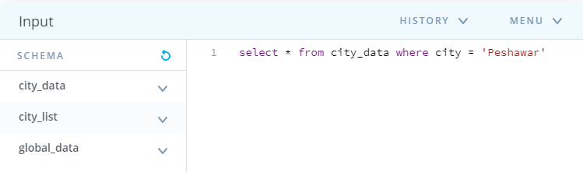

## Moving Averages Calculated:

Below image shows that moving averages were calculated using excel

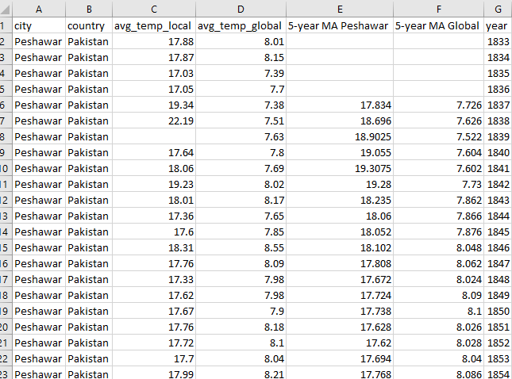

# Line Chart:

Following is the line chart of temperature trends for my city *Peshawar* and global temperature

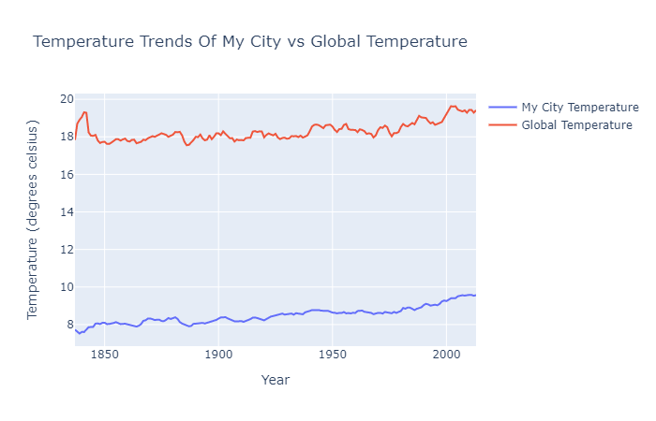

# Observations:

## #1

Is my city hotter or cooler on average compared to the global average? Has the difference been consistent over time?

**Answer**

As can be seen from the graph (line chart) above that the temperature of my city of choice, on average, is far greater than average global temperature.

Thus, we can conclude that my city’s average temperature has always been hotter than global temperature

## #2

Changes in local temperature as compared to global temperature?

**Answer**

Again, from the line chart, we can see that there is more abruptness in local temperature than global temperature (which is quite smooth) indicating that weather of my city is getting warmer quicker than global temperature. It can also be observed from the shape of lines in the chart.

## #3

Changes in local temperature as compared to global temperature?

**Answer**

Again, from the line chart, we can see that there is more abruptness in local temperature than global temperature indicating weather of my city is getting warmer quicker than global temperature. It can also be observed from the shape of lines in the chart.

## #4

Any observation for a specific time period?

**Answer**

From the line chart above, if we look closely, we can see that from the year 1950 and onwards, temperature of my city if quickly rising as compared to global temperature.